KIBO ANDROID APPLICATION

MANUAL TESTING REPORT

Submitted By
Name: Sumit
Roll Number: 24/SCA/MCA/050
Mobile Number: 8708842664
Course: Master of Computer Applications (MCA)

University Name
Rachna International Institute of Research and Studies

Application Details
- Application Name: Kibo Android App
- Platform: Android
- Play Store Link: https://play.google.com/store/apps/details?id=com.trestle.labs.kibo
- Testing Type: Manual Testing
- Academic Session: 2024–2026

1. Objective
The objective of this manual testing report is to evaluate the Kibo Android application to identify functional and usability issues. The report documents observed bugs, test cases for a selected feature, and an OCR analysis report for identity document extraction.

2. Test Environment
- Device: Android Smartphone
- Operating System: Android OS
- Network: Wi-Fi / Mobile Data
- App Version: Latest available version on Play Store

3. Bugs / Issues Identified

Bug 1: “Don’t tell me again” option does not work
- Feature: Instant Access
- Severity: Medium
Steps to Reproduce: 1. Open the Kibo app. 2. Navigate to the Instant Access feature. 3. Observe the information popup. 4. Select the checkbox “Don’t tell me again”. 5. Tap on “Okay”. 6. Exit and reopen Instant Access.
Expected Behavior:
The popup should not appear again once the option is selected.
Actual Behavior:
The popup appears every time Instant Access is opened.
Screenshot
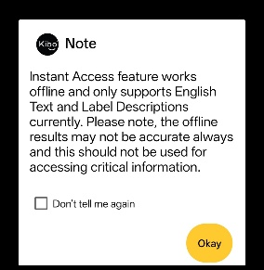

Bug 2: Incorrect object identification and misleading labels
- Feature: Instant Access – Labels
- Severity: Medium
Steps to Reproduce: 1. Open the Kibo app. 2. Navigate to Instant Access. 3. Select the Labels option. 4. Place various objects in front of the camera.
Expected Behavior:
The app should correctly identify and label only the object present.
Actual Behavior:
- Laptop identified as musical instrument or handbag.
- TV remote identified as a mobile phone.
- Cap identified as jeans or shoes.
- Dog identified as dog, cat, or birds.
Screenshot:
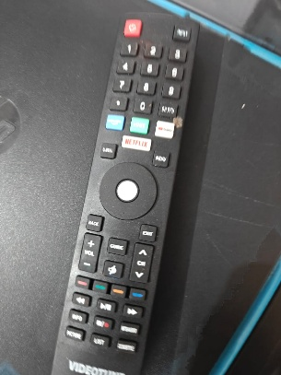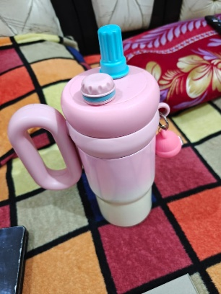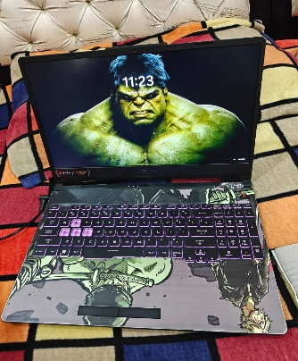

Bug 3: Buttons not responding consistently
- Feature: Multiple modules (My Account, Meditate Now, View Recent Files, Instant Access)
- Severity: High
Affected Buttons: Add, Back, Clear All, Share, Settings
Steps to Reproduce: 1. Open the Kibo app. 2. Navigate through My Account, Meditate Now, View Recent Files, and Instant Access. 3. Tap on the respective buttons.
Expected Behavior:
All buttons should respond immediately and perform their intended action.
Actual Behavior:
- Most buttons do not respond approximately 95% of the time. - Clear All button does not clear recent files. - Buttons in Capture to Read feature work correctly.
Possible Cause:
UI elements may be overlapping with the system notification bar.

4. Selected Feature and Test Cases

Feature Name: Instant Access
Description:
The Instant Access feature allows users to scan objects using the camera and receive labels or extract text from printed content.
Test Cases Summary: - TC-01: Open Instant Access – Pass
- TC-02: Camera permission handling – Pass
- TC-03: Object detection accuracy – Fail
- TC-04: Multiple object detection – Fail
- TC-05: “Don’t tell me again” popup – Fail
- TC-06: Back button functionality – Fail
- TC-07: Performance during scanning – Fail

5. Summary
Manual testing of the Kibo Android application revealed multiple functional and usability issues, mainly in object detection accuracy, popup behavior, and button responsiveness. These issues significantly impact user experience.

6. Recommendations
- Improve object recognition accuracy.
- Fix button responsiveness across the application.
- Correct popup preference saving logic.
- Optimize UI layout to avoid overlap with system bars.
- Enhance overall performance during scanning.

7. Conclusion
The Kibo Android application requires functional and usability improvements. Resolving the identified issues will improve reliability, performance, and user satisfaction.

PAN Card Upload – OCR Result Analysis Report

1. Document Details
- Document Type: PAN Card
- Feature Tested: Read Your Document / OCR Text Extraction
- Testing Type: Manual Testing
- Input Format: PAN Card PDF

2. Steps to Test
- Open the Kibo application.
- Navigate to the “Read Your Document” feature.
- Select PDF format and upload the PAN Card.
- Wait for OCR processing.
- Verify extracted text and formatting.

3. OCR Output
- PAN Number: KCOPS8***N
- Name: SUMIT
- Father’s Name: SURENDER
- Date of Birth: 01/04/2000

4. Expected Behavior
- Accurate extraction of all key fields.
- Structured and readable output.

5. Actual Behavior
- Key fields extracted successfully.
- Output text appeared unstructured.
- Minor alignment and formatting issues observed.

6. Observations and Severity
- Misalignment and merged text – Medium
- Formatting issues – Low
- OCR field accuracy – High

7. OCR Recommendations
- Apply post-OCR text formatting.
- Improve alignment using preprocessing techniques.
- Validate key fields separately for accuracy.

